

CLIFFORD COMMUNITY
PRIMARY SCHOOL AND NURSERY
SEND INFORMATION REPORT
In partnership with the Suffolk Local Offer for SEND

Updated: April 2026
Review date: April 2027

SEND provision

At Clifford Community, we cater for a vast range of SEND needs within the broad areas identified within the Special Educational Needs and Disability Code of Practice 0-25 years. These include:
- Communication and Interaction,
- Cognition and Learning,
- Social, Emotional and Mental health difficulties,
- Sensory and/or physical needs.

How do we identify and assess SEND?

The Code of Practice suggests that pupils are identified as SEND if they have a significantly greater difficulty in learning than peers of the same chronological age, or have a physical or mental impairment which hinders them from accessing facilities or provision in mainstream schools. Children with SEND needs are identified using the graduated approach. This is; identifying needs and providing quality first teaching, monitoring, SEND support, SEND support with external agency support and EHCP.

At Clifford Community we follow the ‘Assess-Plan-Do-Review’ cycle for SEND as outlined in the SEND Code of Practice. We ensure that we monitor progress regularly against national and age related expectations and share this data with parents/carers via termly parents’ meetings. If a teacher is concerned about a pupil, they will discuss their concerns with the SENDCo and the parents/carers, and then the child will be monitored within our graduated approach cycle. Equally, parents/carers themselves may have the initial concerns, and can make contact with the school to discuss them with the class teacher in the first instance.

After being monitored, if a child is identified as needing SEND support, the class teacher, working alongside the SENDCo, will analyse the child’s needs. This analysis will use evidence provided from;
- Teacher assessments over a period of time
- Analysing the child’s progress and development against their age-related expectations or starting point
- Parent/carer views.
- Advice from external agencies (where already involved with the child).

If it is felt that a pupil does require provision that is different or additional to that which is available to other pupils, then the child will be added to the SEND register and a meeting with the parent/ carer will take place to discuss the next steps of what the school can put in place to meet the pupil’s needs. A plan of support, including the One Page Profile and the Learning Plan, will be drawn up. This will be reviewed regularly as it is a continuous process to ensure provision is evaluated and adapted to meet the child’s progress and development.

In rare cases, where a child’s needs are severe or complex, or when they do not make progress over a period of time, despite high quality, targeted support, it may be necessary for special educational provision to be made for the child. In these cases, a statutory assessment referral for an Education, Health Care Plan (EHCP) may be made to the Local Authority.
What is our approach to teaching pupils with SEND?

In most cases, children will have their learning needs met through quality first teaching within their class. The school follows the universal offer, dependent on the level of need:
- Whole Class universal support: High quality teaching with universal support adaptations to remove or overcome barriers to learning. Lessons are planned carefully against the National Curriculum, with adaptations provided to allow all children to succeed against learning outcomes.
- Targeted support: This could include small group support, resources or interventions for children who require additional to or different from, personalised to their learning needs.
- Specialist support: Focused individualised programmes for pupils with barriers to their learning which require high levels of differentiation. Some provision can be made by external agencies, such as Speech and Language or through in house support such as Thrive/ ELSA.

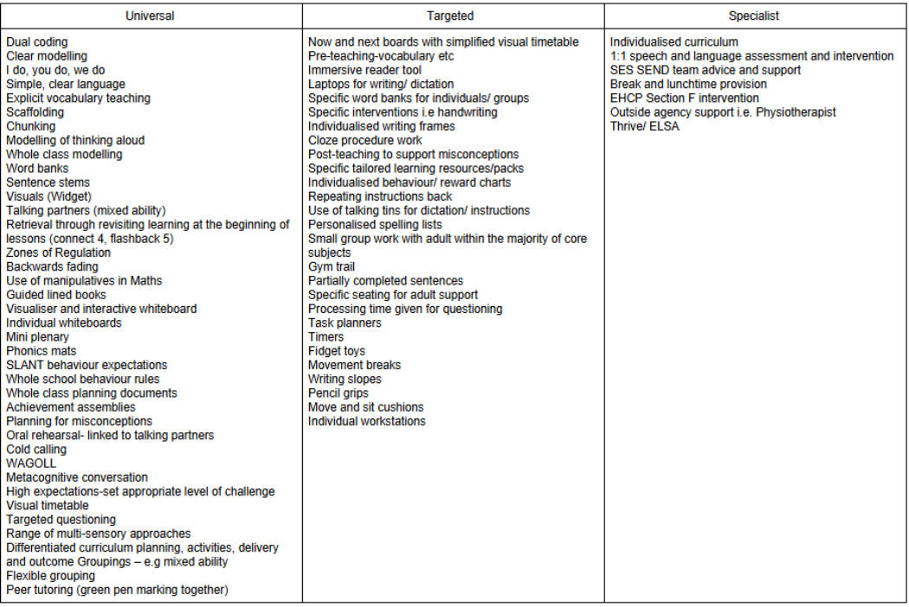

How will the curriculum and environment be adapted for pupils with SEND?

At Clifford Community we endeavour to adapt the curriculum and learning environment to meet individual needs where possible and reasonable. Through our universal offer, we provide adaptations based on the needs of the pupil. When necessary, advice is sought from a range of professionals to ensure appropriate adaptations are made. For children with an EHCP, recommendations will often have been provided within their plan and, alongside professionals, we endeavour to ensure all provisions are considered.

How do we make sure children and young people with SEND do well?

Provision for pupils with SEND is tracked and regularly reviewed and discussed by the SENDCo and the Senior Leadership Team. It is also be shared with the governor for SEND on an anonymised basis. The child’s progress towards their targets will be assessed by the class teacher, with on-going formative assessments taking place during lessons. In addition, summative assessments may be carried out in order to measure the child’s progress towards outcomes. Some assessment tools available within the school are:
- British Picture Vocabulary Scale
- Sandwell Assesment
- Phonological Assessment Battery 2 (PhAB2)
- THRIVE/ ELSA
- York Assessment of Reading Comprehension
- Renfrew

When reviewing progress, we consider; the views of the class teacher and adults working alongside the child, parent/ carer views, analysis of work, progress against the Learning Plan, assessment data from termly testing or specific assessments and feedback from external agencies who provide support for the child. This information will contribute to the review of provision for the child.

If a child has an EHC plan, we will review the plan within every 12 months (dependent on the age of the child and the age of the EHCP) and involve: parents; the child; professionals; the class teacher and the SENDCo in reviewing and implementing revised or additional provision and strategies.

How does the school consult and involve parents and young people with SEND?

Parent/Carer voice:

All parents are able to communicate with the school via:
- Meetings with the class teacher, or other relevant members of staff including the SENDCo in termly Learning Plan meetings.
- Separate opportunities beyond Parents’ evening appointments, with the class teacher (and SENDCo if desired) to discuss SEND concerns.
- EHCP annual reviews.
- Coffee Mornings
Pupil views:
Students are given the opportunity to provide feedback about their education via:

- Providing their views for EHCP reviews.
- Providing their views for their One Page Profiles as part of the Learning Plans.
- Self-assessment.
- During PSHE lessons.
- At transition events to the high school.
How will the school evaluate the effectiveness of the provision for pupils with SEND?

To ensure the highest quality provision for all pupils with SEND, provision is carefully monitored through;
- Termly Pupil Progress Meetings
- Termly data tracking
- Monitoring and observations by the SENDCo and Senior Leadership Team (SLT)
- Book and planning scrutiny by SLT
- Pupil perception interviews
- Learning Plan meetings held each term.
- Regular updates between school and SEND governor
- Formal Governor monitoring visits

How will staff be trained to support pupils with SEND?

All teachers are teachers of SEND and have the opportunity to request information and training in any aspect of SEND that they require. The SENDCo is available to offer support and guidance to teachers in relation to individuals or specific needs and where appropriate, will arrange training for staff; this may be through in-house training or arranging for outside agencies to deliver training. Our current training includes, but is not limited to:
- Beat Dyslexia,
- Thrive/ ELSA
- Autism Awareness
- Epilepsy
- Downs Syndrome awareness
- Diabetes
- Behaviour safe training
- TACPAC
- Musical Communication
- Talking boxes
- Intensive Interaction
- Bucket Time
- Identiplay

Medical conditions

We have staff available in school who are trained to provide basic first aid and those who are trained in paediatric first aid. In instances where more specific training is required to meet a child’s needs, a health care plan will be put in place and full training provided to all relevant staff who will support the pupil. Where relevant, this will be in tandem with advice from medical professionals, if relevant, to ensure that provision is appropriate and accurate.

What outside agencies and support will the school use to help pupils with SEND?

There are a number of services across education, health and social care that we can seek guidance from. Referrals to these services will be made where appropriate, with the consent of the parent/carer. Some of the services are listed below:
- Special Education Services (SES)
- School Nursing Team
- Occupational Therapy
- Physiotherapy (PT)
- Speech and Language Therapy (SALT)
- Educational Psychologists
- Occupational Therapy (OT)
- Primary Mental Health Team (CAMHS)
- Education Access Team
- Ipswich Hospital
- Suffolk Family Carers
- Young Carers
- Multi-Agency Safeguarding Hub (MASH)
- Family Support Worker
- Primary Mental Health Worker

What support is available for improving the emotional and social development of children with SEND?

We recognise that children may need support in their social and emotional development. Our pupils develop these SEMH skills through a range of wellbeing related activities including;
- Zones of Regulation boards and daily activities
- THRIVE interventions/ ELSA support
- A range of resources within classrooms to support social and emotional development including brain breaks.
- Celebration of all in classrooms and through achievement assemblies
- PSHE lessons

How are children with SEND enabled to engage in activities available to children who do not have SEND?

We are an inclusive school and children at Clifford Community have equal access to activities irrespective of their individual needs. We endeavour to provide a range of activities and opportunities to make learning interesting and enjoyable. All trips and visits are carefully considered and planned to allow all pupils, regardless of any SEND, the opportunity to attend. We have local visits and trips, including swimming lessons and reasonable adjustments are made to ensure that they are accessible for all pupils. In Upper Key Stage 2, residential trips are arranged, which are carefully planned to ensure that they are inclusive, as long as it does not compromise on the wellbeing, health or safety of those attending.

How will the school support transition?

We recognise that additional transition support may be required to support our pupils with SEND. All children are supported in moving between phases of their education whether to a new teacher, a new year group or during their transition to other schools. During these transitions, we ensure transition meetings are provided to discuss issues, concerns and questions with the class teacher, SENDCo, parents and child (if appropriate).

When transitioning to high school, the high school SENDCo meets with the SENDCo and Year 6 teachers as early as possible to organise transition plans and set up an appropriate enhanced transition package as needed. In the case of children with an EHCP, a review of the EHCP takes place in the Autumn Term and staff from the appropriate high school are invited.

If a child is moving to a specialist placement, work is conducted with the SENDCo of the new placement and parents to ensure that the transition is supportive to the child and their needs, including an in-depth meeting to discuss the child.

Funding for SEND

We receive a fixed sum for each pupil at the school and in addition can seek financial support from the Local Authority High Tariff Need Funding, on an individual basis.
This amount is then deployed on staffing to support children with SEND, as well as resources and access arrangements.

How will the school handle complaints about SEND?

We take any complaints very seriously and will always strive to resolve these. Please refer to the Complaints Policy for more information.

Who should I contact for more information?

The key people within the school to contact are:
- Your child’s class teacher.
- Our SENDCo, Miss Piper.
- Our Head Teacher, Mr Dadds.
- Our school’s governor for SEND is Amy Barber.

Local offer

The local offer provides information on services children and families can expect from local agencies. The Suffolk Local Offer can be found on the website below.

https://www.suffolklocaloffer.org.uk/

