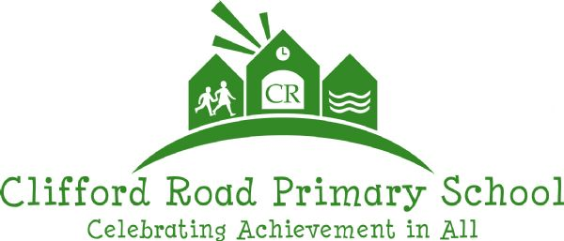
History and Geography at Clifford Road Primary School

- History and Geography is taught following the CUSP curriculum, which aims to ignite student’s love for History and Geography, preparing them with essential knowledge for Key Stage 3 and beyond. All year groups use CUSP Curriculum as the foundational structure for their topics.
- CUSP History and Geography draws upon prior learning, wherever content is taught, allowing connections to be made within and throughout topics. There is a mix of substantive knowledge (focuses on content/facts it deals with the ‘what’ of a subject — the key concepts, theories, facts, and phenomena that make up the subject matter, for example, in history, substantive knowledge would include historical events, dates, and figures) and disciplinary knowledge (the methods, approaches, and frameworks used to investigate, analyse, and interpret information. It emphasises the how of studying the subject, including the skills, tools, and techniques employed in research and inquiry. For example, in history, disciplinary knowledge would include understanding how to analyse primary sources, use historiographical methods, or interpret historical evidence) woven throughout the curriculum which supports an overarching history/geography schema.
- A guiding principle of CUSP History and Geography is that students become ‘more expert’ with each study and grow an ever broadening and coherent mental model of the subjects. This guards against superficial, disconnected and fragmented understanding and knowledge.
- Specific and associated historical and geographical vocabulary is planned sequentially and cumulatively from Year 1 to Year 6. High frequency, multiple meaning words (Tier 2) are taught alongside and help make sense of subject specific words (Tier 3). Each learning module in History and Geography has a vocabulary module with teacher guidance, tasks and resources.
- Teachers can draw upon the broad range of resources, key questions, knowledge organisers (student-friendly unit overview) knowledge notes (student-friendly lesson overview) and subscribed websites – for example digimaps.
- Generally, one history unit and one geography unit is taught fortnightly throughout the term, in each year group across the school. A unit of work is generally approximately between 4 and 8 sessions and broken down into ‘Essential’ or ‘Enrichment’ lessons.
- In the EYFS, History and Geography is taught through the ELG of ‘understanding the world’. Students learn about the past and present through daily activities, exploring through change, and understanding more about the lives of others through books and visitors as well as their own experiences. These experiences are drawn upon and used to position new learning in KS1. In geography, EYFS students learn about People, Culture and Communities or The Natural World through daily activities and exploring their locality and immediate environment. The studentren’s interests lead teacher planning resulting in a flexible curriculum.

Memorable Moments/ Enrichment Opportunities

Teachers will plan ‘hook’ or ‘memorable moments’ to enrich student experiences in History and Geography units.

This might involve an immersive day, trip or visitor that enhances, builds upon and supports student’s ability to retain the key knowledge in each unit.
Assessment
- Teachers will draw upon a wide range of formative assessment strategies to make judgements about how securely each student’s knowledge and understanding has developed during and at the end of a topic.
- From CUSP plans, we snip and use Thinking Historically/Geographically Challenges as a task for some lessons per topic, which provide a mini assessment focus and extended writing opportunities.
- Regular use of knowledge quizzing is used to assess retrieval of key vocabulary and knowledge.
- Each unit quiz to be used as a summative assessment opportunity once a unit has been taught.
- Teachers record judgements against the information in the unit plans using the school’s PITA assessment criteria (1-4 WTS, 5 EXS, 6 GDS). These judgements are recorded cumulatively at the end of the year on the school’s internal tracker system and shared with parents in their End of Year reports.
- Magic 5s are used to record down 5 key knowledge facts (established with the class) following the teaching of a unit of work. Magic 5 Flashbacks are to be used to support students with their retrieval of learnt knowledge from previous units Magic 5s in the same academic year and previous academic years.

History and Geography Champions
Claire (History) and Amanda (Geography) are our History and Geography Champions, they: promote the subject identifying best practice in school and beyond; set the highest expectations and model best practice; provide colleagues with knowledge and understanding to help enrich the experience for students; monitor the quality of teaching and learning; and play a leading role in the long term and medium-term planning across the school.

Subject Ambassadors: Mrs Crossley (History) Mrs Norris (Geography) - Link Governor: tbc

Monitoring Cycle
Autumn 1 | Autumn 2 | Spring 1 | Spring 2 | Summer 1 | Summer 2
Data analysis  Subject action plan | Planning scrutiny  Subject on a page | Resource review  Learning walk | Work sampling  Student perceptions | Subject champion/SLT/Governor meeting | Policy review

What a good lesson looks like in History and Geography
A good history or geography lesson under the CUSP curriculum framework is one that engages students in active learning with rich, meaningful content, challenges them to think critically, and helps them build both knowledge and skills in a collaborative, inquiry-based learning environment.
Here’s a breakdown of what a strong lesson might look like:

At the beginning of a unit
- Knowledge Organiser to be stuck into each student’s book at the beginning of each unit.
- It would be great for teachers to talk through the Knowledge Organiser as it will provide an opportunity to expose the students to the content.
- It will also enable students a reference point for future learning.
- The Knowledge organiser also acts as a signpost in student’s books for when a unit begins and finishes.

At the beginning of each lesson
- Use the start of the lesson as an opportunity to look back at the Knowledge Organiser and previous learning from the unit.
- The Knowledge Note for the lesson to be stuck into each student’s book, covering over the margin.
- It would be great for teachers to talk through the Knowledge Note as it will provide an opportunity to expose the students to the content and provide them with a reference point for learning throughout the lesson.
- CUSP have written Dual Knowledge Notes for each lesson. That means there is a Securing (less sophisticated) and an Advancing (original) note for each lesson to support adaptive teaching. The learning question is the same.
- All the Printable Securing and Advancing Knowledge Notes can be found at the end of each module.

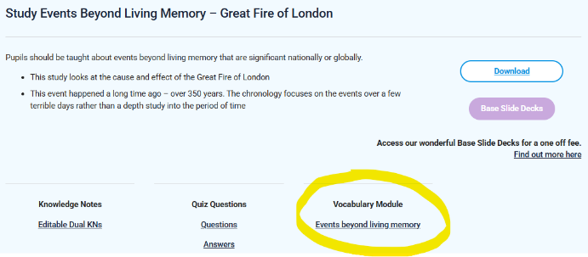
Vocabulary
- Spending time teaching the students about the vocabulary of a unit is really important and is recommended at the beginning and throughout a unit.
- An overview of the vocabulary to be taught for each unit can be found within the Vocabulary module on the CUSP page for each unit.
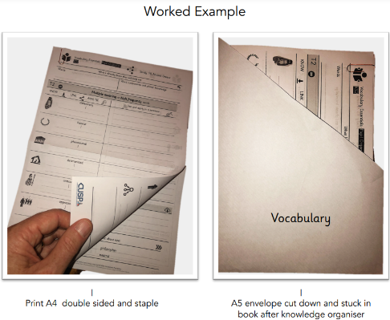
- The Base Slide Desks are a good starting point for teaching vocabulary within each lesson of a unit – these can be adapted to suit teachers and their students.
CUSP Base Slide Decks can support teachers and students in developing a generic routine for exploring vocabulary. The vocabulary slides are structured to model and develop the explicit teaching of vocabulary in every lesson.
- Teaching of vocabulary can be recorded in the exercise book for each lesson next to the Knowledge Notes.

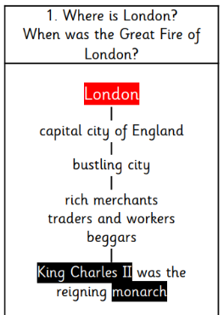
Clear Learning Focus
- The lesson will begin with a clear, concise learning question – located at the top of each Knowledge Note. For example:
  - History: "By the end of the lesson, you will be able to explain where London is and when the Great Fire of London was."

Engagement and Stimulus
- The lesson or unit could start with an engaging hook, such as an interesting question, artifact, image, video, or story that sparks curiosity.
  - In history, you could show an image of an ancient artifact or a compelling video clip from a historical event.
  - In geography, you might use satellite imagery, maps, or case studies of current environmental issues.

Memorable Moments/ Enrichment Opportunities
- Do plan in ‘hook’ or ‘memorable moments’ at the start or within the unit to enrich student experiences in History and Geography units.
- This might involve an immersive day, trip or visitor that enhances, builds upon and supports student’s ability to retain the key knowledge in each unit.

Active Learning
- Students should be encouraged to engage with the content actively. This could be through group discussions, debates, hands-on activities, or project work.
  - History: Students might analyse primary sources, discuss the perspectives of different historical figures, or re-enact historical events.
  - Geography: Students could analyse data (such as population density maps or climate change graphs), work on map skills, or conduct fieldwork if possible.

Use of Skills and Knowledge
- The CUSP curriculum emphasises building both knowledge and skills. For history, this means students not only learn about historical events but also practice skills like historical inquiry, analysis of sources, and argument construction.
  - History: Activities might involve using a range of sources to investigate historical questions or creating a timeline of key events.
  - Geography: Students might interpret maps, analyse geographical patterns, and work with geographical tools like GIS or physical models.

Supporting all learners
- Effective lessons will cater to different levels of ability, ensuring all students are appropriately challenged. This could mean providing extension tasks for more advanced students using the CUSP Thinking Historically/Geographically Challenges as a task or offering additional support for those who need it.

Critical Thinking and Discussion
- A good lesson encourages students to think critically about historical or geographical topics. This can be facilitated through structured debates, discussions, or problem-solving tasks.
  - In history, students could debate a controversial historical decision or consider the implications of a historical event from different viewpoints.
  - In geography, students might evaluate the sustainability of a certain human practice or consider the social, political, and environmental implications of geographical issues.
- Students should be given opportunities to reflect on their learning and demonstrate their understanding through tasks like writing a short response, creating a presentation, or participating in a group discussion.
- From CUSP plans, we can snip and use Thinking Historically/Geographically Challenges as a task for some lessons per topic, which provide mini assessment and extended writing opportunities.

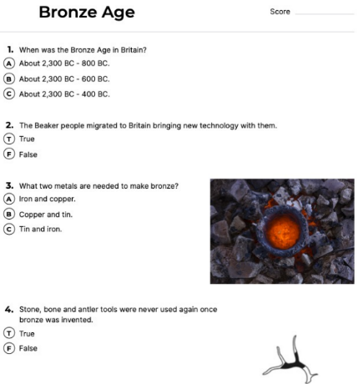
End of lesson quiz
- Regular use of knowledge quizzing is used to assess retrieval of key vocabulary and knowledge.
- At the end of each lesson use the Cumulative quiz (which can be found within each unit plan) as a great AfL opportunity to identify what the students have learnt since the beginning of the unit and within the lesson.
- The quiz can be recorded by students on whiteboards, or evidence recorded into the students’ books. The quiz can also be conducted as an oral activity.

Closing Reflection
- At the end of the lesson, students should have time to reflect on what they’ve learned. This could be through a class discussion or individual reflection, linking back to the lesson's objectives.
  - History: "What are the key lessons we can learn from the Industrial Revolution?"
  - Geography: "How do we contribute to environmental change, and what can we do to help?"

At the end of a unit
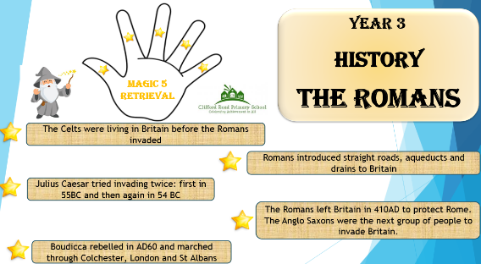
- Each unit quiz to be used as a summative assessment opportunity once a unit has been taught and kept as a record of student attainment.
- Create a Magic 5 with your class for each History and Geography unit taught.
- Magic 5’s are used to record down 5 key knowledge facts (established with the class) following the teaching of a unit of work.
- Each Magic 5 will then be used for future retrieval practice through our Magic 5 Flashbacks.

Following a unit
- Use Magic 5 Flashbacks once a week with your class (15 minutes) as a regular opportunity to support students with their retrieval of learnt knowledge from previous units using the Magic 5s from the same academic year and previous academic years.
- Magic 5 Flashbacks enable students to recall key facts from History and Geography units taught:
  - Weeks following a unit being taught; one month following; one term following; one year following; years following

At the end of the year
- Teachers record assessment judgements against the information in the unit plans using the school’s PITA assessment criteria (1-4 WTS, 5 EXS, 6 GDS). These judgements are recorded cumulatively at the end of the year on the school’s internal tracker system and shared with parents in their End of Year reports.

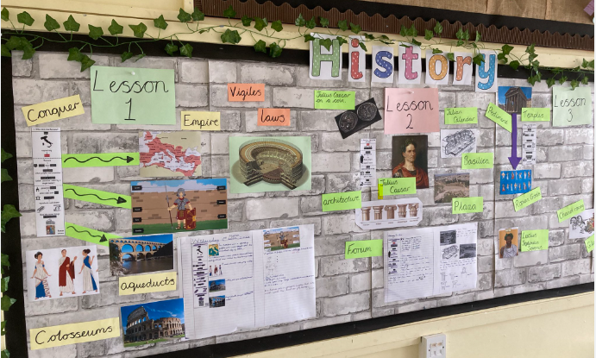
Classroom Displays
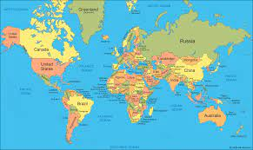
- All classes have a world map displayed and refered to in their classrooms.
- Key vocabulary to be dislayed.
- Knowledge organiser/notes to be displayed.
- Timeline of key historical dates to be displayed.
- Examples of children’s work.

Talk like a Historian and Geographer
Spoken Language in the National Curriculum:
- Pupils should learn to justify ideas with reasons; ask questions to check understanding; develop vocabulary and build knowledge; negotiate; evaluate and build on the ideas of others; and select the appropriate register for effective communication.
- They should be taught to give well-structured descriptions and explanations and develop their understanding through speculating, hypothesising and exploring ideas. This will enable them to clarify their thinking as well as organise their ideas for writing.

History In Key Stage 1:
- Pupils should develop an awareness of the past, using common words and phrases relating to the passing of time.
- They should use a wide vocabulary of everyday historical terms.
- They should ask and answer questions, choosing and using parts of stories and other
- sources to show that they know and understand key features of events
History In Key Stage 2:
- Pupils should regularly address and sometimes devise historically valid questions about change, cause, similarity and difference, and significance.
- They should construct informed responses that involve thoughtful selection and organisation of relevant historical information.

History Sentence Stems – KS1 | History Sentence Stems – KS2
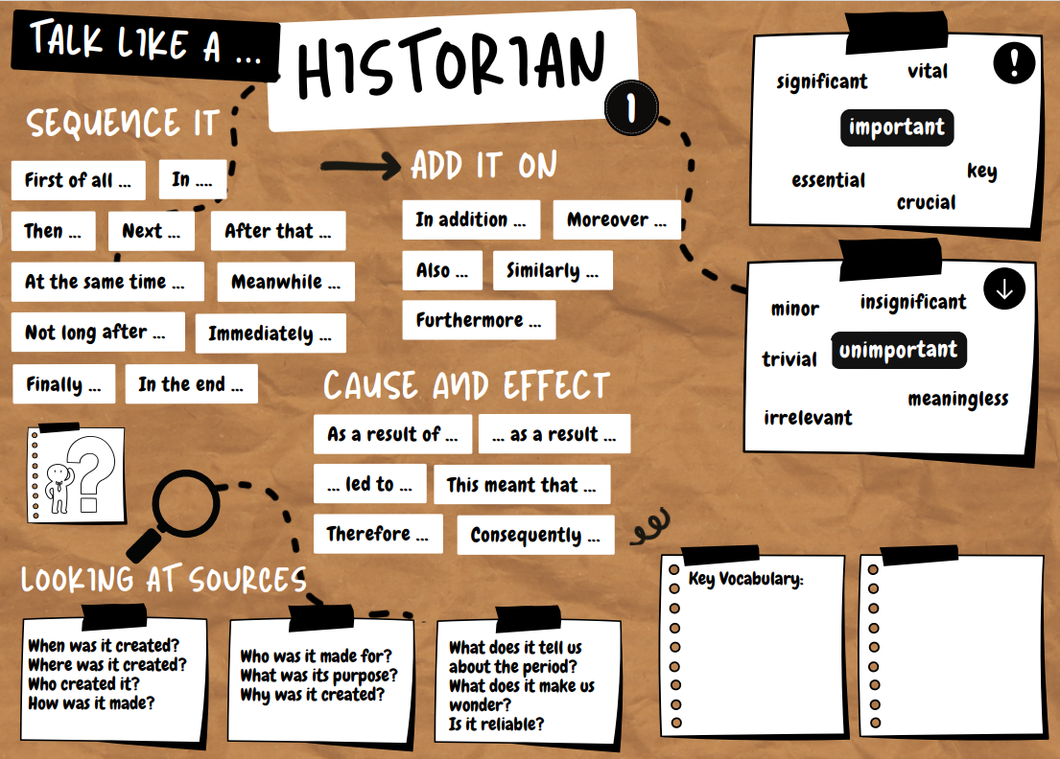 | 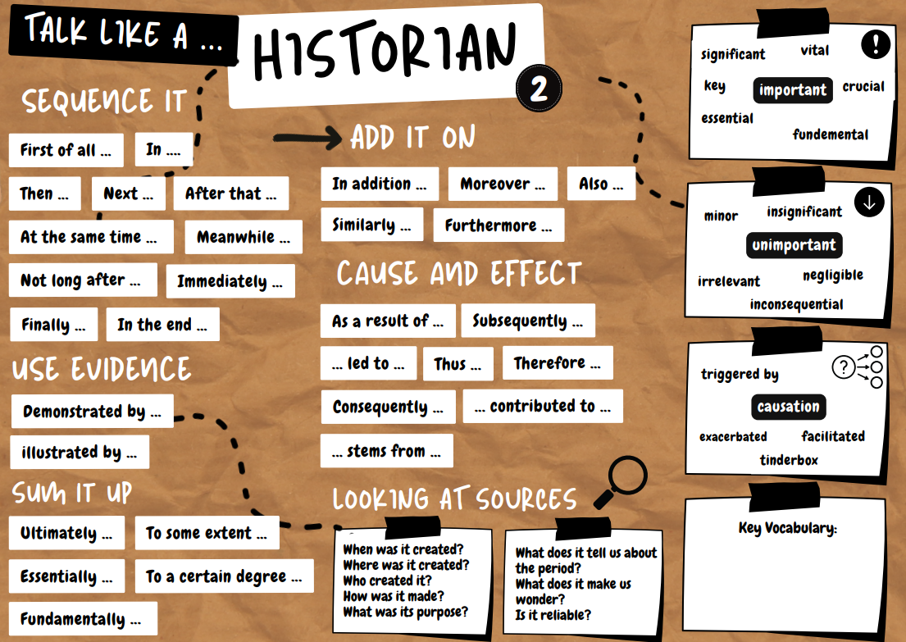

Geography in Key Stage 1:
- Pupils should be taught to develop knowledge about the world, the United Kingdom and their locality.
- They should understand basic subject-specific vocabulary relating to human and physical geography and begin to use geographical skills, including first-hand observation, to enhance their locational awareness.
Georgraphy in Key Stage 2:
- Pupils should extend their knowledge and understanding beyond the local area to include the United Kingdom and Europe, North and South America.
- This will include the location and characteristics of a range of the world’s most significant human and physical features.
- They should develop their use of geographical knowledge, understanding and skills to enhance their locational and place knowledge.

Geography Sentence Stems – KS1 | Geography Sentence Stems – KS2
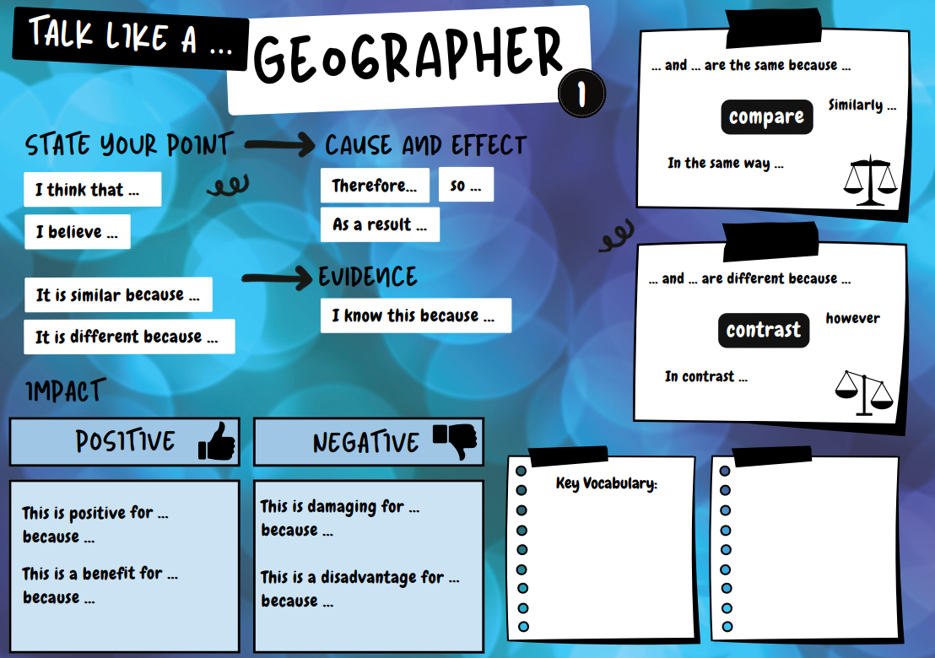 | 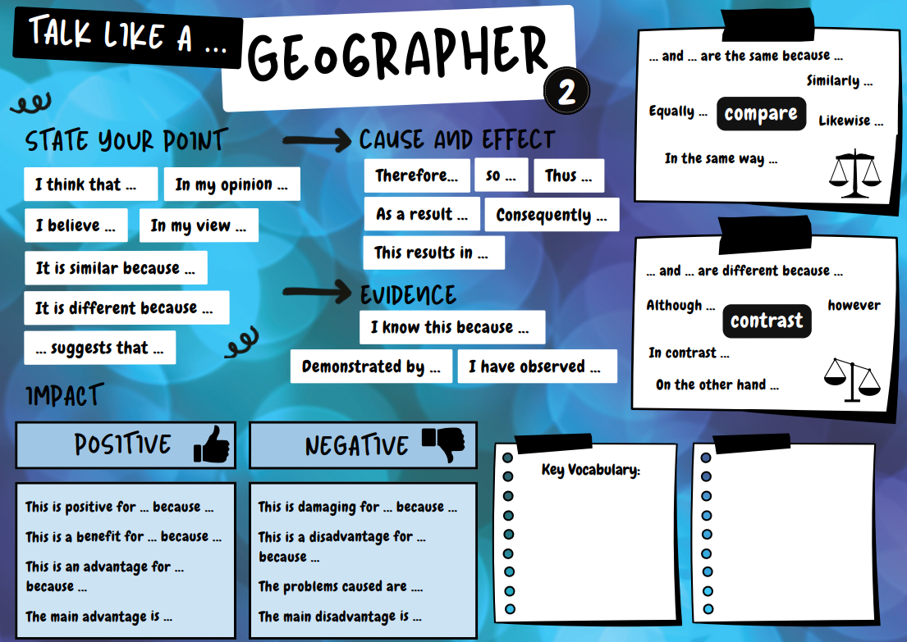

Reading as a Historian and Geographer
We subscribe to Curriculum Visions to support high-quality non-fiction texts that can also be accessed at home.
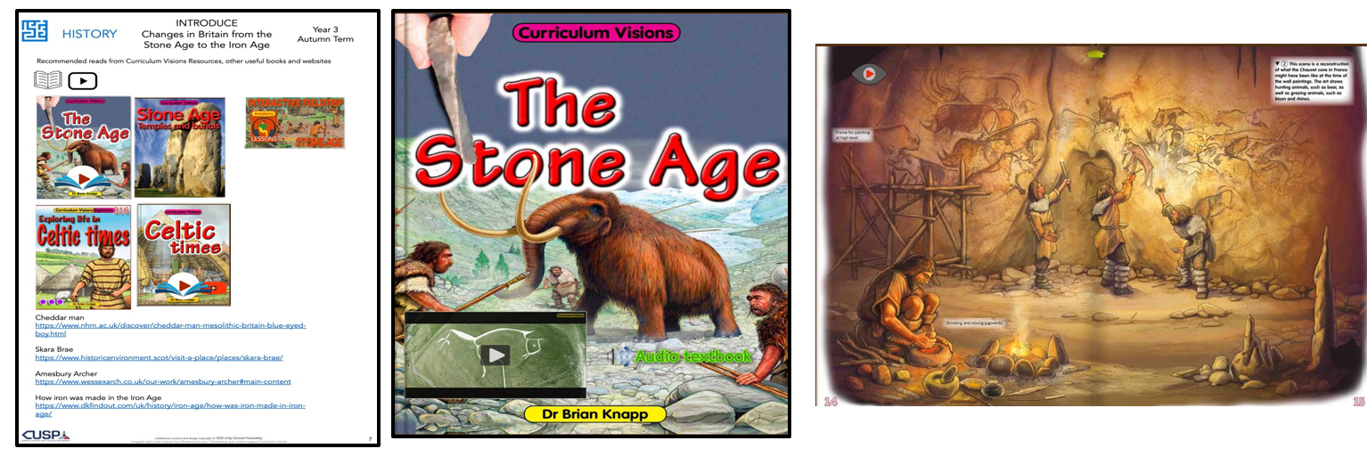
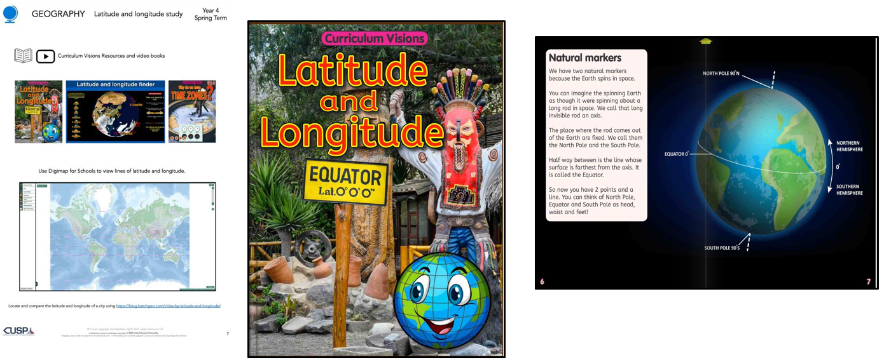

 | History  Long Term Plans
Year 1
CUSP History  - Changes within living memory  5 essential lessons  +1 enrichment lesson | - The lives of significant people (Mary Anning and David Attenborough)  4 essential lessons  +1 enrichment lesson | - More lives of significant people  (Neil Armstrong, Mae Jemison, Bernard Harris Jr, Tim Peake.)  3 essential lessons

Year 2
- Events beyond living memory - Great Fire of London  4 essential lessons  +2 enrichment lessons | - Significant historical events, people, places in our locality - Ipswich Unit on CUSP  5 essential lessons  +2 enrichment lessons | - Revisit – Events beyond living memory (or alternative focus for insecure knowledge)  2 essential lessons  +1 enrichment lessons

Year 3
- Stone Age – Iron Age  5 essential lessons  + 3 enrichment lessons | - Rome and the impact on Britain  5 essential lessons  + 3 enrichment lessons | - Revisit Changes in Britain from Stone Age to the Iron Age  3 essential lessons

Year 4
- Britain’s settlement by Anglo-Saxons and Scots  4 essential lessons  + 2 enrichment lessons | - Viking and Anglo-Saxon struggle for the Kingdom of England to the time of Edward the Confessor  5 essential lessons  +3 enrichment lessons | - Ancient civilisation – Egypt  6 essential lessons  +3 enrichment lessons

Year 5
- Ancient Greece  6 essential lessons  +3 enrichment lessons | - Comparison study – Maya and Anglo-Saxons  8 essential lessons  +1 enrichment lessons

Year 6
- Beyond 1066  - Local History Study - how did conflict change our locality in World War 2?  4 essential lessons  +2 enrichment lessons | - Windrush generation  4 essential lessons  +2 enrichment lessons | - 5 significant monarchs  1 essential lessons  +5 enrichment lessons

Geography
Long Term Plans

Year 1
- Continents  - Oceans  - Countries of UK  - Capital cities of UK  - Seas around UK  5 essential lessons  +1 enrichment lessons | - Hot and cold places  4 essential lessons  +2 enrichment lessons | - Mapping and fieldwork  3 essential lessons  +1 enrichment lessons  - Revisit Continents, Oceans, UK countries, Capital Cities and Seas  3 essential lessons

Year 2
- Human and Physical features  2 essential lessons  +1 enrichment lesson  - Compare a small part of the UK to a non-European location – London and Nairobi  4 essential lessons  +2 enrichment lessons | - Fieldwork and map skills  5 essential lessons  +1 enrichment lesson | - Compare a different non-European location to our locality - Amazon Rainforest  2 essential lessons  +1 enrichment lesson

Year 3
- KS2 fieldwork and map skills – physical and human geography  2 essential lessons  +1 enrichment lesson  - OS map skills and fieldwork  3 essential lessons  +1 enrichment lesson | - UK Study  5 essential lessons  +1 enrichment lesson | - Revisit countries, counties and regions of the UK  3 essential lessons  +1 enrichment lesson

Year 4
- Rivers (Y4)  2 essential lessons  +1 enrichment lesson  - Latitude and longitude (Y4)  5 essential lessons  +2 enrichment lessons | - Water cycle (Y4)  3 essential lessons | - Map skills & Study the environmental regions of Europe, Russia, North and South America (Y4)  5 essential lessons  +1 enrichment lessons  - Revisit rivers  2 essential lessons  +1 enrichment lessons

Year 5
- World countries – biomes and environmental regions  4 essential lessons  +2 enrichment lessons | - 4 and 6 figure grid references  2 essential lessons  +1 enrichment lessons | - OS maps and fieldwork  4 essential lessons  +2 enrichment lessons  - Revisit locations and biomes – Including biomes and environmental regions  3 essential lessons

Year 6
- Physical processes - Earthquakes, mountains and volcanoes  5 essential lessons  +1 enrichment lesson | - Human and Physical Geography: Economic, settlement and trade links  5 essential lessons  - UK, Europe and N America comparison study  4 essential lessons  +2 enrichment lessons | - OS Maps and fieldwork (orienteering)  3 essential lessons  +3 enrichment lessons

